**The stomach**

**Part 1**

*Anatomy and physiology*

1. Please label the diagram below

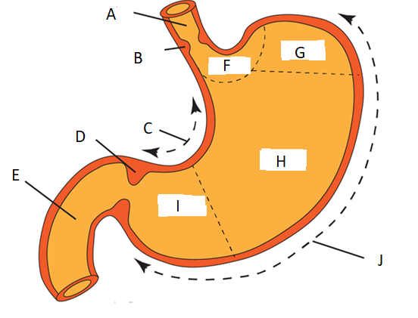

|  |  |
| --- | --- |
| A |  |
| B |  |
| C |  |
| D |  |
| E |  |
| F |  |
| G |  |
| H |  |
| I |  |
| J |  |

1. What is the role of the stomach?

|  |
| --- |
|  |

1. Fundic, or oxyntic, glands are the primary secretory glands of the stomach. Please describe the role of the different types of cells found within the gland.

|  |  |
| --- | --- |
| **Cell** | **Role** |
| Mucous |  |
| Parietal |  |
| Chief |  |
| Enteroendocrine | G cell:  D cell: |

1. What is the mechanism by which the following acid suppressing medications reduce acid secretion in the stomach?

|  |  |  |  |
| --- | --- | --- | --- |
| **Group** | **Example** | **Standard dose (mg)** | **Mechanism of action** |
| PPIs |  |  |  |
| H2 Receptor antagonists |  |  |  |

1. A 45-year-old patient with diarrhoea, weight loss, abdominal pain and a history of GORD is seen in clinic. He undergoes gastroscopy, which shows multiple ulcers within the stomach. Following high dose PPI therapy, he is re-scoped and no improvement is seen.

What is the likely diagnosis here? What is the cause of this syndrome, and how is the diagnosis confirmed?

|  |
| --- |
|  |

**Part 2**

1. Below are the 2 commonest causes of peptic ulcers. How do they cause damage to the stomach lining?

|  |  |
| --- | --- |
| H. Pylori |  |
| NSAIDs |  |

1. In acute upper GI bleed, the Glasgow Blatchford Score (GBS) is recommended by the BSG as the best scoring system pre-endoscopy to predict need for hospital-based intervention or death. A patient with a score of 1 or less may be managed on an outpatient basis.

Can you complete the list of parameters that are used in the GBS.

|  |
| --- |
| Haemoglobin (men/women) |
|  |
|  |
| Heart rate >100bpm |
|  |
|  |
|  |
| Cardiac failure |

1. The BSG recommends very few instances where antibiotic prophylaxis prior to endoscopic procedures is recommended (see guidance here: <https://gut.bmj.com/content/58/6/869>). In acute upper GI bleed, which group of patients **should** receive antibiotic therapy?

|  |
| --- |
|  |

1. In peptic ulcer disease, the Forrest classification can be used to guide choice of endoscopic therapy and predict the risk of re-bleeding. It also provides a standardised mechanism by which endoscopists can report their findings. Below are images of peptic ulcers with their Forrest classification below.

Please complete the following table:

|  |  |  |
| --- | --- | --- |
| Forrest classification | Description | Re-bleed risk (%) |
| 1A |  |  |
| 1B |  |  |
| 2A |  |  |
| 2B |  |  |
| 2C |  |  |
| 3 |  |  |

1. A patient with pernicious anaemia undergoes upper GI endoscopy. She has typical endoscopic features of chronic atrophic gastritis (CAG). Please list 3 typical endoscopic features of CAG:
2. The Sydney protocol should be followed when taking biopsies of suspected CAG to confirm the diagnosis and for risk stratification at surveillance. From which areas of the stomach should biopsies be taken, according to the Sydney protocol?

|  |
| --- |
| 1.  2.  3.  4. |

1. Please list 5 risk factors for gastric adenocarcinoma

|  |
| --- |
|  |
|  |
|  |
|  |
|  |

1. The Correa cascade provides a model for the progression from normal mucosa to gastric cancer. Please complete the diagram below.

A =

B =

C =